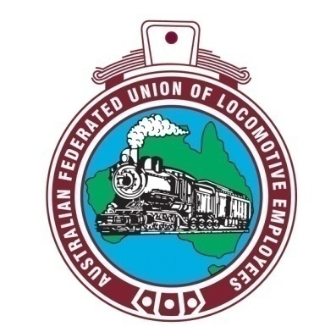
AUSTRALIAN FEDERATED UNION OF
LOCOMOTIVE EMPLOYEES

Circular: 40/18

Ref: NW OT Finalised

23/04/2018

North West Overtime Dispute Finalised

Dear Traincrew,

In early 2016 the then AFULE Divisional Councillor for the Townsville/ North West line – Peter Robbins - commenced a dispute with Aurizon in regards to payment for excess hours worked. After in excess of two years of disputation, today Aurizon agreed to terms for back pay to be paid to union members of Mt. Isa, Cloncurry, Hughenden and former Charters Towers Townsville drivers.

This has been a long journey and Aurizon threw many hurdles at both the AFULE and RTBU to dodge paying what was owed to our members.

The significant settlement figure is in excess of $180,000 to de divided between the members of both unions that were members at the time of the dispute from late 2015 – early 2016. Members that have left the job or moved to another depot that were members at the time of the dispute will also be included/ entitled to the sum of back pay.

Thank you for being patient with us as we pursued this extensive dispute with many hours of work put into ensuring your rights were protected.

Members will be contacted shortly to organise the paperwork needed to receive the back pay sum.

If you wish to discuss this matter, please contact me on 3844 9163 or at organiser@afule.org.au.

In solidarity,

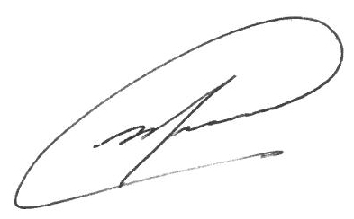
Mick McKitrick
AFULE Organiser

Don’t forget to like us on Facebook.

